**ASSIGNMENT 1**

**1.Clients Table**

Stores details about each client.

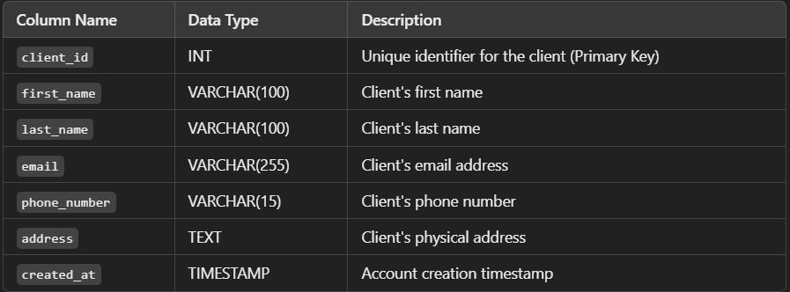

2.Stocks Table

Stores details about individual stocks.

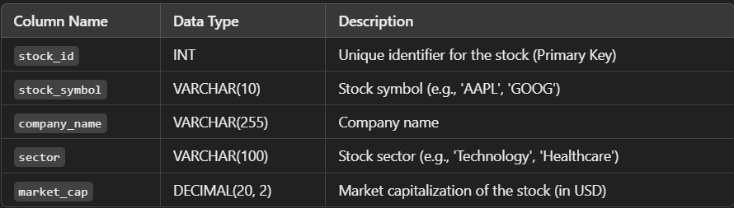

3.Portfolios Table

Stores information about portfolios associated with each client

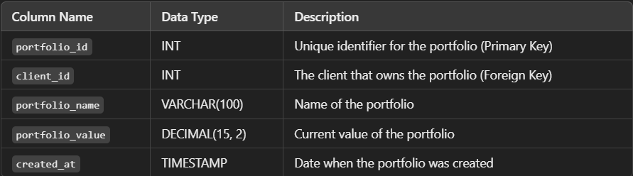

4.Transaction Table

Tracks all stock transactions (buy/sell) within a portfolio.

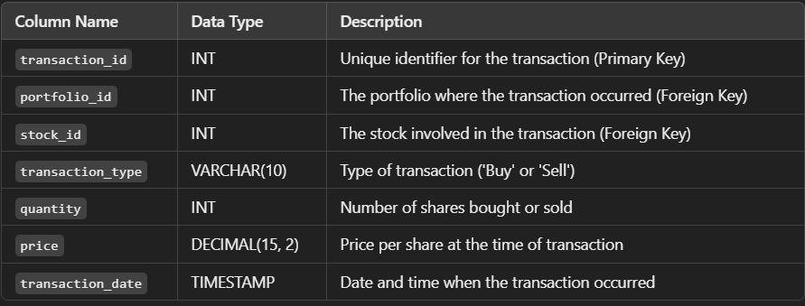

5.Risk assessements Table

Stores calculated risk scores for each portfolio, based on historical stock performance and volatility.

